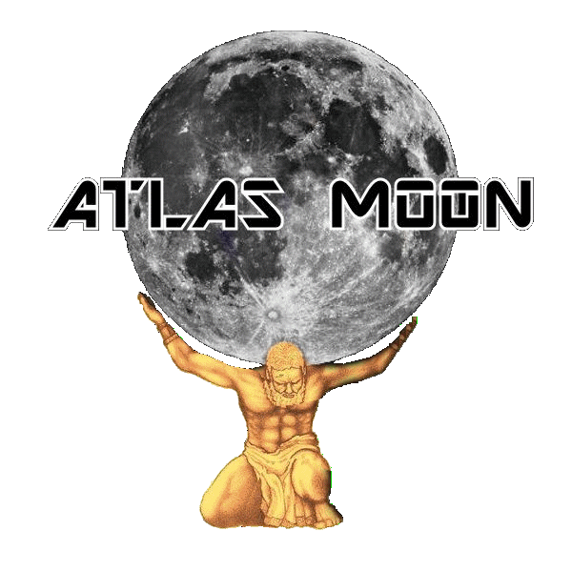 ONE SHEET
Band Bio: Atlas Moon is a new Rock band from Central Florida. The band is the new project of Chris Hendren and Mark Nielsen formerly of the popular Orlando band 3 Bucksworth. Adding Jeff "Loopy" Wroblewski and Dave Pettengill, revamping their repertroire of covers as well as new original Atlas Moon Music along with each band members technical proficiency to their craft, place them in the upper level of local talent in Orlando and abroad.
Timeline:
March 5th 2016 – Atlas Moon opens the show for 38 Special at the 98.9 WMMO Downtown Concert Series in Orlando Florida.
March 13th 2016 – Atlas Moon enters the Studio with producer Brett Hestla (Creed, Dark New Day, Virgos Merlot) to record their self-titled Debut EP.
July 16th 2016 – Atlas Moon back in the studio with Brett Hestla working on their next, as of yet unnamed, CD.
November 16th 2016 – Atlas Moon releases their self-titled debut CD Atlas Moon.
December 16th, 2016 – Atlas Moon hold official CD release party at the Copper Rocket in Orlando Florida. Interviewed by LIVE Orlando.
January 24th 2017 – Atlas Moon are interviewed and songs played on WPRK, Rollins College Radio station in Orlando Florida.
October 28th 2017 – Atlas Moon performs at Seminole Harley Davidson for Harley-Davidson Demo Days concert.
November 19th 2017 – Atlas Moon gets airplay on Bud 94.1 FM’s Monday Night Local radio show.
December 18th 2017 – Atlas Moon are the first “Repeat Offenders” to be aired on Bud 94.1 FM’s Monday Night Local radio show.
December 22nd 2017 – Atlas Moon enters Good N Plenty internet radio’s song rotation.
Present – Atlas Moon continues work on their second CD and performing live shows at various venues in and outside of Central Florida.

Social Media Links:
Official Website: http://www.atlasmoonband.com
Facebook: https://www.facebook.com/AtlasMoonband
ReverbNation: https://www.reverbnation.com/atlasmoonband
Twitter: https://twitter.com/AtlasMoonBand
Sound Cloud: https://soundcloud.com/atlas_moon
YouTube: https://www.youtube.com/channel/UCJex5cnOqn2g_zrPf_xCDxA
Instagram: https://www.instagram.com/atlasmoon/

Contact Information: Booking and inquiries: John Douce – 407-758-6405
Band Email – atlasmoonband@gmail.com

